*Submitted by* **Hareesh Reddi** *Roll Number:* **150101051 (Coursera Videos) Traces Link:** [**https://drive.google.com/open?id=1zv2mSDiTi_gFswT7EizOlJT5CD9BysON**](https://drive.google.com/open?id=1zv2mSDiTi_gFswT7EizOlJT5CD9BysON)

**Question1:**

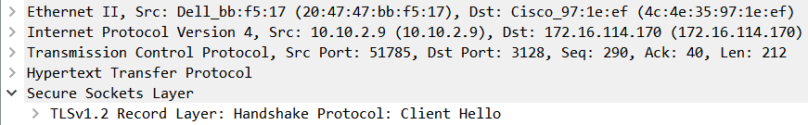**Various protocols** used by the functions like Play, Download of application Coursera Video are

**1)** Transport Layer**: TCP 2)** Network Layer**: IPV4 3)** Application Layer**: HTTP**

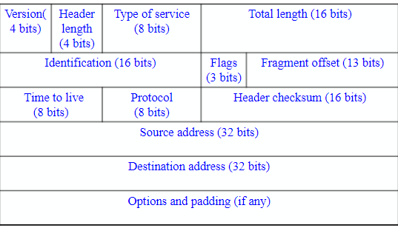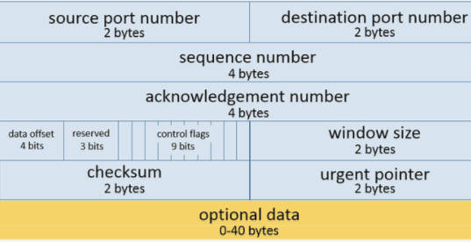 **4)** Secure Socket/Session Layer**: TLSv 1.2 Protocol 5) Physical Layer: Ethernet II Protocol 1&2) Figures** on the **left side, right side** indicates frame format of **TCP** and **IPV4** respectively.

I described all the fields of both the protocol Frame Formats in **second answer**.

**3) HTTP header format:** HTTP messages consist of requests from client to server and responses from server to client.

HTTP-message = **<*Request*> | <*Response*>; HTTP/1.1 messages**

Request and Response messages use the generic message format of RFC 822 for transferring entities (the payload of the message). This generic message format consists of the following four items.

* **Start-line**: Request Line or Status Line.
* **Zero or more header fields followed by CRLF**: The headers are as follows: General Header, Response Header, Request Header and Entity Header.
* **An empty line**: indicating the end of the header fields
* Optionally a **message-body**: It is used to carry the entity-body associated with the request or response.

**4) Secure Session Layer(Record Layer)** : This layer acts as an intermediate between transport layer and application layer. It deals with session and connection coordination. TLS 1.2 was defined in [RFC 5246](https://tools.ietf.org/html/rfc5246) in August 2008. **Packet Format**:

* **Content type**: The type field is identical to TLSCompressed.type.
* **Version**: The version field is identical to TLSCompressed.version.
* **Length**: The length (in bytes) of the following TLSCiphertext.fragment. The length MUST NOT exceed 2^14 + 2048.
* **Fragment**: The encrypted form of TLSCompressed.fragment, with the MAC.
* **Message Authentication Code (MAC)**: It is a one-way hash computed from a message and some secret data. It is difficult to forge without knowing the secret data. Its purpose is to detect if the message has been altered.

**5) Ethernet II Protocol Frame Format:**

|  |  |  |  |  |  |  |  |
| --- | --- | --- | --- | --- | --- | --- | --- |
| **DA** | **SA** | **Type** | **DSAP** | **SSAP** | **Ctrl** | **Data** | **FCS** |
| **6 Bytes** | **6 Bytes** | **2 Bytes** | **1 Byte** | **1 Byte** | **1 Byte** | **>46 Bytes** | **4 Bytes** |

The fields are as follows: 1) **DA** [Destination MAC Address] 2) **SA** [Source MAC Address] 3) **Type** [0x8870 (Ether type)] 4) **DSAP** [802.2 Destination Service Access Point] 5) **SSAP** [802.2 Source Service Access Point] 6) **Ctrl** [802.2 Control Field] 7) **Data** [Protocol Data] 8) **FCS**[Frame Checksum]

**Question 2:**

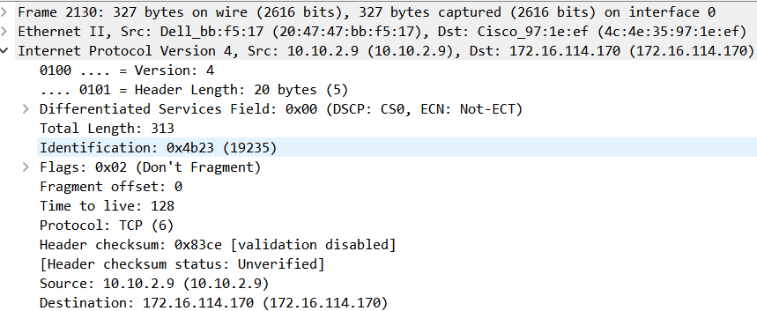

**1) Frame 2130:** The frame number of the trace I took for observation is 2130. The frame protocol is **not a real protocol** itself, but used by Wireshark as a base for all the protocols on top of it. We also have information about the bytes used by the frame (327 bytes)

**2) Ethernet II:**  **Src: Dell_bb:f5:17 (20:47:47:bb:f5:17)** : Hardware Mac address of my PC (Source). **Dst: Cisco_97:1e:ef (4c:4e:35:97:1e:ef)** : Hardware mac address of destination. **3) Internet Protocol Version 4: Src : 10.10.2.9** – This is my computer IP address(Source IP Address). **Dst: 172.16.114.170** – This destination computer IP address. Here, I used the proxy address for internet connection (Destination IP Address). These IP addresses help us to uniquely identify both machines on the network. **Version: 4**: field indicates the format of the internet header. **Header length: 20 bytes**: Number of 32-bit words in the TCP header. **Differentiated Services Field** (DSF): **0x00**: Indicates particular Quality of Service needs from the network, the DSF defines the way routers should queue packets while they are waiting to be forwarded. **Total Length: 313:** is the length of the datagram, measured in octets, including internet header and data. This field allows the length of a datagram to be up to 65,535 octets**. Flags: 3 bits**, Various Control Flags: **Bit 0**: reserved, must be zero **Bit 1**: (DF) 0 = May Fragment, 1 = Don't Fragment **Bit 2**: (MF) 0 = Last Fragment, 1 = More Fragments. **Fragment Offset: 0 bits**: This field indicates where in the datagram this fragment belongs. **Time to live: 128:** This field indicates the maximum time the datagram is allowed to remain in the internet system. Field called **Protocol** (Same as protocol number): **TCP (6)**: To identify the next level protocol used. **Header checksum: 0x83ce**: A checksum on the header only and its status is unverified.

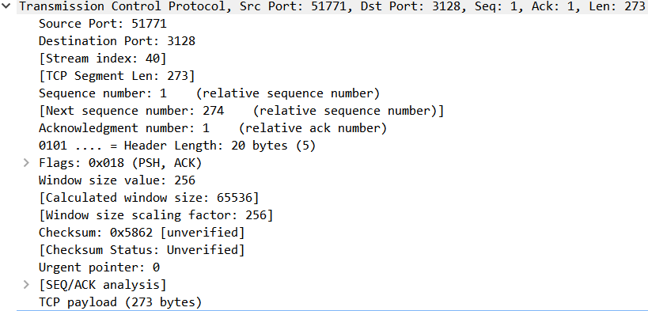

**4)** **Transmission Control Protocol**:

* **Src Port: 51711**: My computer port in this case, which is sending packets.
* **Dst Port: 3128**: This is receiving/Destination port which is receiving packets.
* **TCP Segment Length: 273**: This is TCP packet segment length.
* **Sequence number: 1**: If the SYN flag is set (1), then this is the initial sequence number. The sequence number of the actual first data byte and the acknowledged number in the corresponding ACK are then this sequence number plus 1.
* **Acknowledgment number: 1**: The ACK flag is set to 1 which means the value of this field is the next sequence number that the sender is expecting.
* **Flags (9 bits):** It contains 9 1-bit flags. **ACK** (1 bit)**:1**: indicates that the Acknowledgment field is significant. All packets after the initial SYN packet sent by the client should have this flag set. **PSH** (1 bit)**:1**: **Push function**. Asks to push the buffered data to the receiving application. Remaining seven flags i.e. NS, CWR, ECE, URG, RST, SYN, FIN have value 0.
* **Window size value: 256**: This is the space for the incoming data.
* **Checksum (16 bits):0x5862**: The 16-bit checksum field is used for error checking of the header and data.
* **Urgent pointer (16 bits)**: **0**: If the URG flag is set, then this 16-bit field is an offset from the sequence number indicating the last urgent data byte.

**5)** **TLSv1.2 Protocol: Transport Layer Security** (**TLS**): Some of the fields of the protocol can be seen.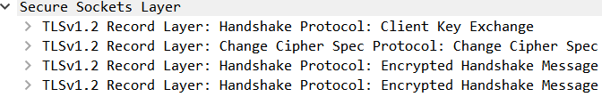 Some other messages includes **Client Hello, Server Hello, Certificate, Server Key Exchange, Server Hello Done** between **client** (10.10.2.9) and **server** (172.16.114.170) and TLS is implemented on two levels- The

TLS Record protocol and the TLS Handshake protocol to ensure **security, efficiency and extensibility**.

**6) Hypertext Transfer Protocol**: 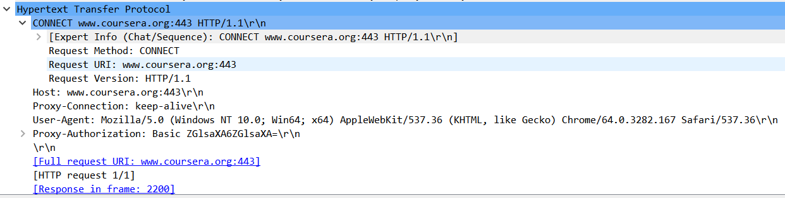

* **CONNECT www.coursera.org:443 HTTP/1.1\r\n**: This is start line, indicating it is request packet.
* **Request Method**: The CONNECT method converts the request connection to a transparent TCP/IP tunnel, usually to facilitate SSL-encrypted communication (HTTPS) through an unencrypted HTTP proxy.
* **Host:** www.coursera.org:443\r\n: This tells hostname to which requesting the packet.
* **User-Agent**: Mozilla/5.0 (Windows NT 10.0; Win64; x64) AppleWebKit/537.36 (KHTML, like Gecko) Chrome/64.0.3282.167 Safari/537.36\r\n: This is part of requesting header. Tells about host information about the browser and operating system**.**

**Question3:**  **a) 3-Way TCP Handshake Message sequence**: Before a client attempts to connect with a server, the server must first bind to and listen at a port to open it up for connections: this is called a passive open. Once the passive open is established, a client may initiate an active open. Establishing a normal TCP connection requires three separate steps: **1) SYN**: The client sending a SYN to the server performs the active open. The **client** sets the segment's sequence number to a random value **A**. **2) SYN-ACK**: In response, the **server replies with a SYN-ACK**. The acknowledgment number is set to one more than the received sequence number i.e. **A+1**, and the sequence number that the server chooses for the packet is another random number, **B**. **3) ACK**: Finally, the client sends an ACK back to the server. The sequence number is set to the received acknowledgement value i.e. **A+1**, and the acknowledgement number is set to one more than the received sequence number i.e. **B+1**.  **b) TLS Handshaking Message Sequence observed:**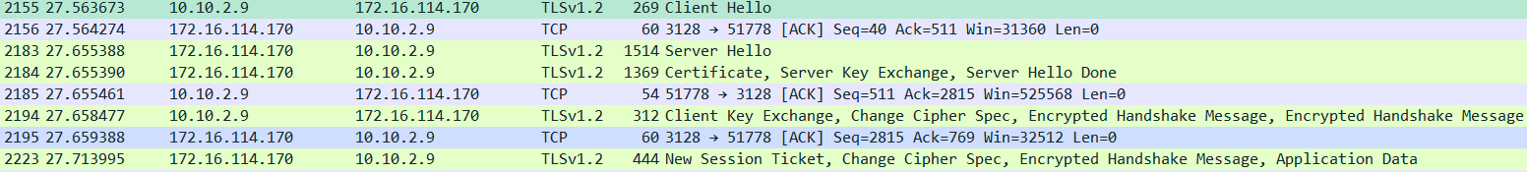

The record encapsulates a "control" protocol (the handshake messaging protocol) when the TLS connection starts. This protocol is used to exchange all the information required by both sides for the exchange of the actual application data by TLS and to negotiate the **secure attributes of a session**. It defines the messages formatting or containing this information and the order of their exchange. These may vary according to the demands of the client and server. The TLS Handshake protocol allows **authenticated communication** to commence between the server and client. This protocol allows the client and server to speak the same language, allowing them to agree upon an **encryption algorithm and encryption keys** before the selected application protocol begins to send data. We can see **various messages** i.e. Client Hello, Server Hello, Certificate, Server Key Exchange, Server Hello Done, Client Key Exchange, Change Cipher Spec, Encrypted Handshake Message b/n **client** (10.10.2.9) and **server** (172.16.114.170). As **Coursera Videos** was not mentioned any particular function, I chose **Play, Running and Download functions** for carrying the observations, as Upload is only available to Professors.

**a) Play & Running Functions**: This function shows a sequence of TCP connection establishment through 3-way handshake, then a HTTP request to the host **d3c33hcgiwev3.cloudfront.net**:443 HTTP/1.1. This got response from TCP after a TLS handshake to ensure security. Work of **Play** button finishes here where as when video is **running** it gives response through continuously getting TCP data transfer and obtaining application data.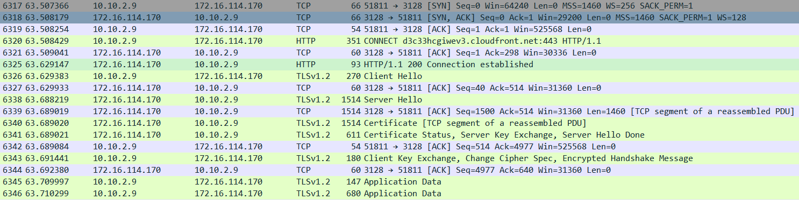

**b) Download Function**: After clicking on the download button, initially connection is established through 3-way handshake, then a HTTP request to the host d3njjcbhbojbot.cloudfront.net:443 HTTP/1.1. Then followed by TLS handshake. Finally, **TCP segments** started being transferred from server to our computer.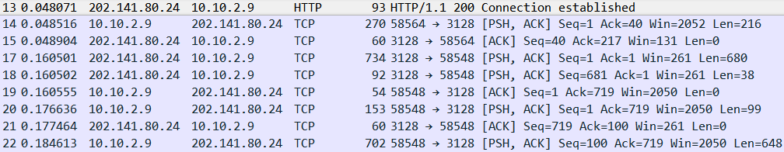

**Question4:** Protocols used by our network to Play, Download the Coursera Videos are explained below with their functions. The protocols used were **TCP, HTTP and TLSv1.2**.

**a)** **TCP**: Its responsibility includes end-to-end message transfer independent of the underlying network and structure of user data, along with error control, segmentation, **flow control**, and helps to minimize **traffic congestion** control. It is a connection-oriented protocol that addresses numerous **reliability** issues in providing a reliable byte stream: data arrives in-order, data has minimal error (i.e., correctness), duplicate data is discarded and lost or discarded packets are resent. TCP is optimized for **accurate delivery** rather than timely delivery, as correct sequence of buffer to be fetched. TCP's bandwidth probing and congestion control will attempt to use all of the available bandwidth between server and client.

**b)** **HTTP**: TCP works in the **Transport layer** while HTTP works in **Application layer** of TCP/IP model. TCP is in charge of setting up a reliable connection between two machines and HTTP uses this connection to transfer data between the web servers and the client in the communication process, we can say connection is fundamentally out of scope of HTTP as it is controlled at Transport Layer. HTTP is a **stateless protocol** though not sessionless, meaning that the server does not keep any data (state) between two requests/each request message can be understood in isolation. HTTP follows a classical **client-server model**, with a client opening a connection to make a request, then waiting until it receives a response. HTTP is an **extensible protocol** that is easy to use. The client-server structure, combined with the ability to simply add headers, allows HTTP to **advance** along with the extended capabilities of the Web. Usually, HTTP responses are **buffered** rather than streamed. **HTTP 1.1** added supports for streaming through keep-alive header so data could be streamed. HTTP is Media independent i.e. any type of data can be sent by HTTP as long as both the client and the server know how to handle the data content.

**c) TLSv1.2**: TLS was designed to operate on top of a reliable transport protocol such as TCP. Web servers use cookies to identify the web user. They are small piece of data stored into the web user’s disk. TLS is used to protect **session cookies** on the rest of the sites from being intercepted to protect user accounts. The TLS protocol aims primarily to provide **privacy** and **data integrity** between two communicating computer applications. SSL and TLS are both cryptographic protocols utilizing X.509 certificates, public/private key encryption that provide **authentication** and **data encryption** between servers, machines and applications operating over a network. TLS provides verification of **identity** of server, which is as important as encryption. The goals of the TLS protocol are cryptographic **security**, **extensibility**, and relative **efficiency**. These goals are achieved through implementation of the TLS protocol on **two** levels: the TLS Record protocol and the TLS Handshake protocol. TLS allows the peers to negotiate **a shared secret key** without having to establish any prior knowledge of each other, and to do so over an unencrypted channel, Client-server applications use the TLS protocol to communicate across a network in a way designed to prevent eavesdropping and tampering.

**Question5:**

**Playing Function:**

|  |  |  |  |
| --- | --- | --- | --- |
| **Details** | 01:07 AM(Lab Proxy :172.16.114.170) | 03:27 PM(Room Proxy:202.141.80.24) | 06:02 PM(Room Proxy: 202.141.80.24) |
| Throughput(in bytes/sec) | 64k | 302k | 1219k |
| RTT(in ms) | 0.1 | 0.921 | 0.901 |
| Packet Size(in Bytes) | 561.5 | 1118.5 | 1052.5 |
| No.of packets lost | 0 | 0 | 0 |
| No.of UDP Packets | 2166 | 683 | 30 |
| No.of TCP Packets | 6773 | 9276 | 9698 |
| No.of responses per one request sent | 1 | 1 | 1 |

**Download Function:**

|  |  |  |  |
| --- | --- | --- | --- |
| **Details** | 03:05 PM(Room Proxy: 202.141.80.24) | 04:36 PM(Jio Wi-Fi) | 09:11 PM(Room Proxy:202.141.80.24) |
| Throughput(in bytes/sec) | 386k | 115k | 1219k |
| RTT(in ms) | 0.813 | 0.23 | 0.901 |
| Packet Size(in Bytes) | 1062.5 | 950.5 | 1052.5 |
| No.of packets lost | 0 | 0 | 0 |
| No.of UDP Packets | 233 | 124 | 30 |
| No.of TCP Packets | 8587 | 13707 | 9698 |
| No.of responses per one request sent | 1 | 1 | 1 |

I am attaching graphs to show **RTT and Throughput** when I used Lab Proxy for Playing Video.

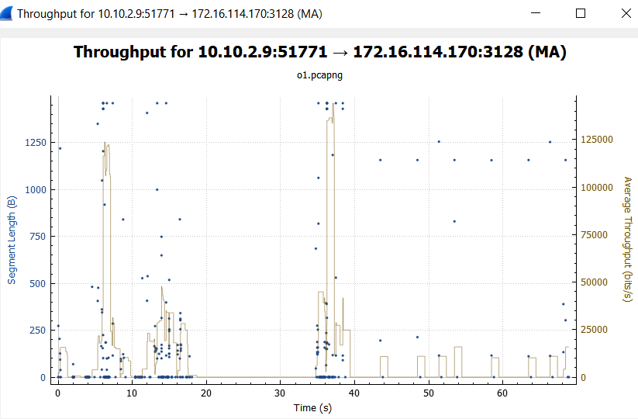 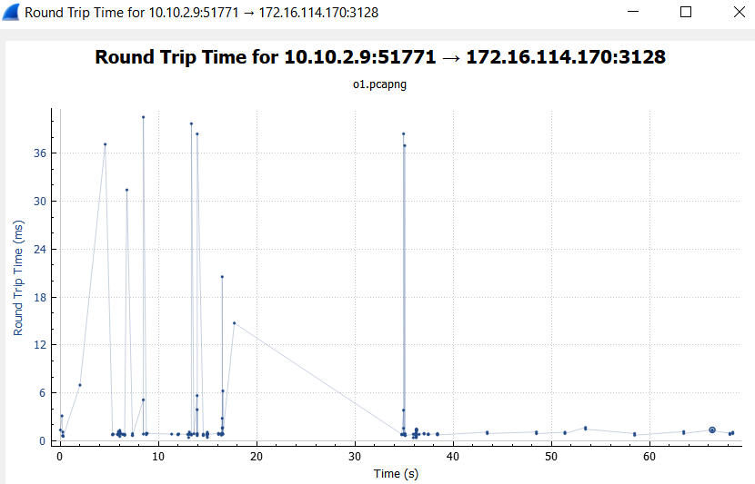

**Question6:** We **cannot** check whether the whole content is being sent from same location **if** we are running the Wireshark **behind a proxy**. So while downloading/Playing the videos from Coursera Website, Destination and Source address would be one of the proxy server address and my computer IP address. If we trace the website **coursera.org** we will find different server IP’s. A **proxy server** is an intermediate program or computer used when navigating through different networks of the Internet. They facilitate access to content on the World Wide Web. A proxy intercepts requests and serves back responses. In **real scenarios** content can be sent from different location/source because of **fast switching** with it, after a packet has been sent to the next hop, the **routing information** about how to get to the destination is stored in a fast cache. When the router receives another packet that is directed to the same destination, it uses the cache, which is faster than the traditional way. So, now suppose some router IP address is selected from the routing table which was used earlier and now is **found to be** **inactive then another router IP address will be selected**, so the routes to same host during the day **can be Different** and content can be provided from **various locations**. When I used **Jio Wi-Fi**,I found **multiple content providers**, their IP Addresses are 52.222.128.123(www-cloudfront-alias.coursera.org), 13.107.21.200(a-0001.a-msedge.net), 52.71.181.107, 23.213.64.35(e10663.g.akamaiedge.net), 172.217.163.174 (clients.l.google.com).